Use Serverless for Apache Spark to Load BigQuery
experimentLabschedule45 minutesuniversal_currency_altNo costshow_chartIntroductory
infoThis lab may incorporate AI tools to support your learning.

Overview
Serverless for Apache Spark is a fully-managed service that makes it easier to run open source data processing and analytics workloads without the need to manage infrastructure or manually tune workloads.
Serverless for Spark provides an optimized environment designed to easily move existing Spark workloads to Google Cloud.
In this lab you will run a Batch workload on the Serverless for Apache Spark environment. The workload will use a template to process an Avro file to create and load a BigQuery table.

What you'll do
- Configure the environment
- Download lab assets
- Configure and execute the Spark code
- View data in BigQuery

Setup

Before you click the Start Lab button
Note: Read these instructions.
Labs are timed and you cannot pause them. The timer, which starts when you click Start Lab, shows how long Google Cloud resources will be made available to you.
This Google Skills hands-on lab lets you do the lab activities yourself in a real cloud environment, not in a simulation or demo environment. It does so by giving you new, temporary credentials that you use to sign in and access Google Cloud for the duration of the lab.

What you need
To complete this lab, you need:
- Access to a standard internet browser (Chrome browser recommended).
- Time to complete the lab.
Note: If you already have your own personal Google Cloud account or project, do not use it for this lab.
Note: If you are using a Pixelbook, open an Incognito window to run this lab.

How to start your lab and sign in to the Console
- Click the Start Lab button. If you need to pay for the lab, a pop-up opens for you to select your payment method. On the left is a panel populated with the temporary credentials that you must use for this lab.
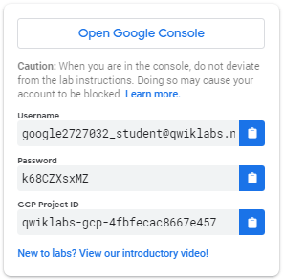
- Copy the username, and then click Open Google Console. The lab spins up resources, and then opens another tab that shows the Choose an account page.
- Note: Open the tabs in separate windows, side-by-side.
- On the Choose an account page, click Use Another Account. The Sign in page opens.
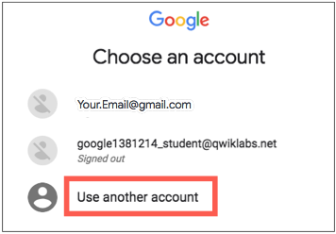
- Paste the username that you copied from the Connection Details panel. Then copy and paste the password.
Note: You must use the credentials from the Connection Details panel. Do not use your Google Skills credentials. If you have your own Google Cloud account, do not use it for this lab (avoids incurring charges).
- Click through the subsequent pages:
- Accept the terms and conditions.
- Do not add recovery options or two-factor authentication (because this is a temporary account).
- Do not sign up for free trials.
After a few moments, the Cloud console opens in this tab.
Note: You can view the menu with a list of Google Cloud Products and Services by clicking the Navigation menu at the top-left. 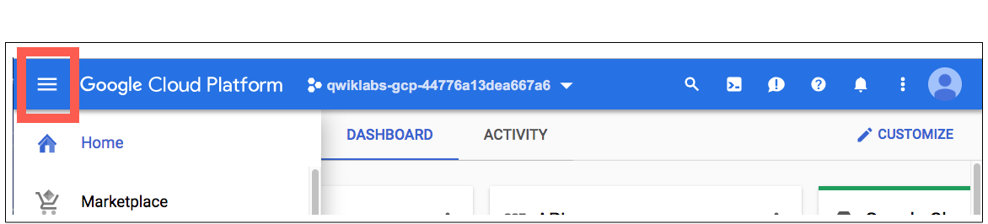

Activate Google Cloud Shell
Google Cloud Shell is a virtual machine that is loaded with development tools. It offers a persistent 5GB home directory and runs on the Google Cloud.
Google Cloud Shell provides command-line access to your Google Cloud resources.
- In Cloud console, on the top right toolbar, click the Open Cloud Shell button.
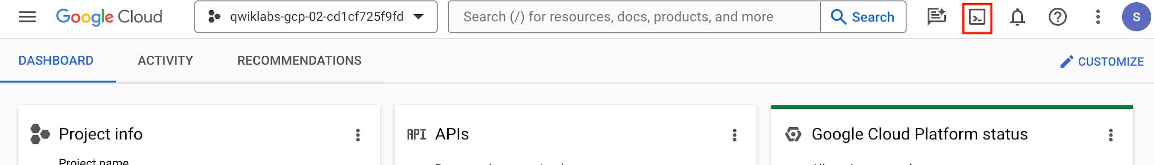
- Click Continue.
It takes a few moments to provision and connect to the environment. When you are connected, you are already authenticated, and the project is set to your PROJECT_ID. For example:
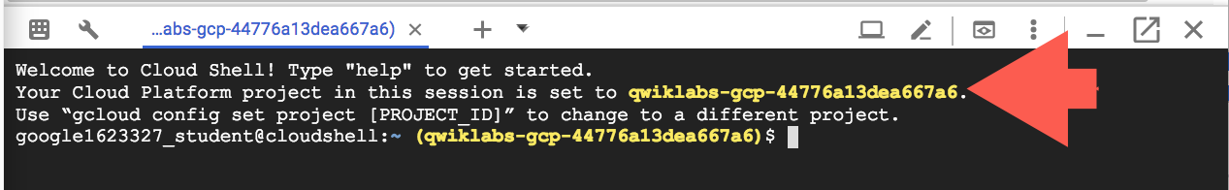
gcloud is the command-line tool for Google Cloud. It comes pre-installed on Cloud Shell and supports tab-completion.
- You can list the active account name with this command:
gcloud auth list
Copied!
Output:
Credentialed accounts:
- <myaccount>@<mydomain>.com (active)
</mydomain></myaccount>
Example output:
Credentialed accounts:
- google1623327_student@qwiklabs.net
- You can list the project ID with this command:
gcloud config list project
Copied!
Output:
[core]
project = <project_id>
</project_id>
Example output:
[core]
project = qwiklabs-gcp-44776a13dea667a6
Note: Full documentation of gcloud is available in the gcloud CLI overview guide .

Task 1. Complete environment configuration tasks
First, you're going to perform a few environment configuration tasks to support the execution of a Serverless for Apache Spark workload.
- In the Cloud Shell, run the following command to enable Private IP Access:
gcloud compute networks subnets update default --region=REGION --enable-private-ip-google-access
Copied!
- Use the following command to create a new Cloud Storage bucket as a staging location:
gsutil mb -p PROJECT_ID gs://PROJECT_ID
Copied!
- Use the following command to create a new Cloud Storage bucket as temporary location for BigQuery while it creates and loads a table:
gsutil mb -p PROJECT_ID gs://PROJECT_ID-bqtemp
Copied!
- Create a BQ dataset to store the data.
bq mk -d loadavro
Copied!
Complete environment configuration tasks

Task 2. Download lab assets
Next, you're going to download a few assets necessary to complete the lab into lab provided Compute Engine VM. You will perform the rest of the steps in the lab inside the Compute Engine VM.
- From the Navigation menu click on Compute Engine. Here you'll see a linux VM provisioned for you. Click the SSH button next to the lab-vm instance.
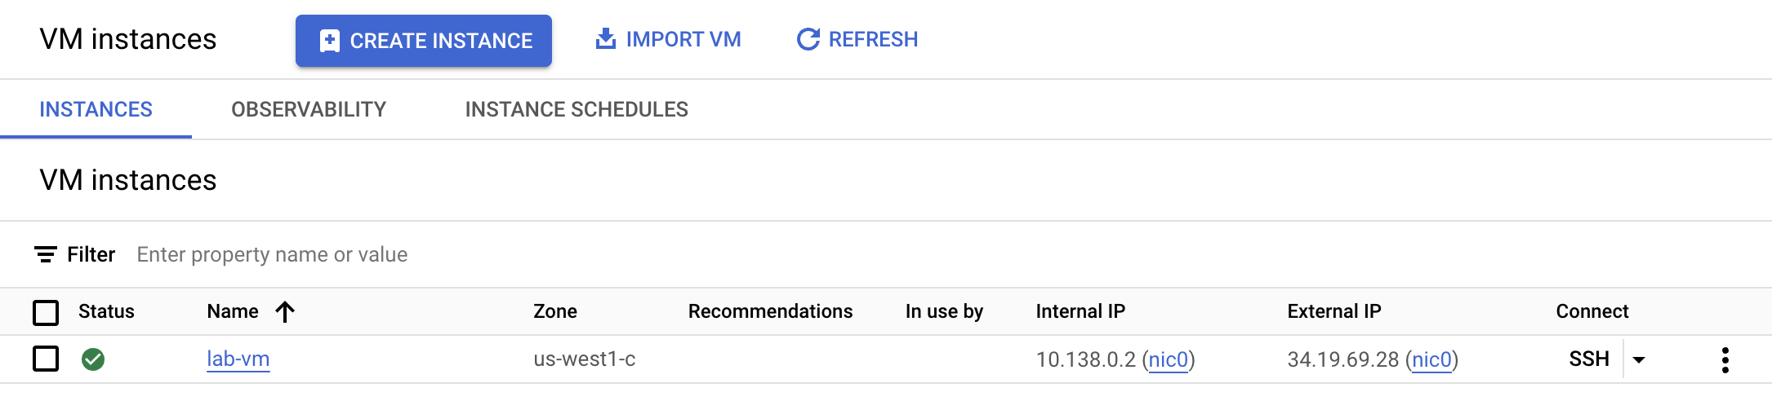
- At the VM terminal prompt, download the Avro file that will be processed for storage in BigQuery.
wget https://storage.googleapis.com/cloud-training/dataengineering/lab_assets/idegc/campaigns.avro
Copied!
- Next, move the Avro file to the staging Cloud Storage bucket you created earlier.
gcloud storage cp campaigns.avro gs://PROJECT_ID
Copied!
- Download an archive containing the Spark code to be executed against the Serverless environment.
wget https://storage.googleapis.com/cloud-training/dataengineering/lab_assets/idegc/dataproc-templates.zip
Copied!
- Extract the archive.
unzip dataproc-templates.zip
Copied!
- Change to the Python directory.
cd dataproc-templates/python
Copied!
Download lab assets

Task 3. Configure and execute the Spark code
Next, you're going to set a few environment variables into VM instance terminal and execute a Spark template to load data into BigQuery.
- Set the following environment variables for the Serverless for Apache Spark environment.
export GCP_PROJECT=PROJECT_ID
export REGION=REGION
export GCS_STAGING_LOCATION=gs://PROJECT_ID
export JARS=gs://cloud-training/dataengineering/lab_assets/idegc/spark-bigquery_2.12-20221021-2134.jar
Copied!
- Run the following code to execute the Spark Cloud Storage to BigQuery template to load the Avro file in to BigQuery.
./bin/start.sh \
-- --template=GCSTOBIGQUERY \
--gcs.bigquery.input.format="avro" \
--gcs.bigquery.input.location="gs://PROJECT_ID" \
--gcs.bigquery.input.inferschema="true" \
--gcs.bigquery.output.dataset="loadavro" \
--gcs.bigquery.output.table="campaigns" \
--gcs.bigquery.output.mode=overwrite\
--gcs.bigquery.temp.bucket.name="PROJECT_ID-bqtemp"
Copied!
Note: You may safely ignore any warning stating: WARN FileStreamSink: Assume no metadata directory. Error while looking for metadata directory in the path... Because this is a small test, a metadata directory is not required.
Note: If you see an error message stating that the batch job has failed, please wait, then re-run the command until the job succeeds.
Configure and execute the Spark code

Task 4. Confirm that the data was loaded into BigQuery
Now that you have successfully executed the Spark template, it is time to examine the results in BigQuery.
- View the data in the new table in BigQuery.
bq query \
--use_legacy_sql=false \
'SELECT * FROM `loadavro.campaigns`;'
Copied!
- The query should return results similiar to the following:
Example output:
+------------+--------+---------------------+--------+---------------------+----------+-----+
| created_at | period | campaign_name | amount | advertising_channel | bid_type | id |
+------------+--------+---------------------+--------+---------------------+----------+-----+
| 2020-09-17 | 90 | NA - Video - Other | 41 | Video | CPC | 81 |
| 2021-01-19 | 30 | NA - Video - Promo | 325 | Video | CPC | 137 |
| 2021-06-28 | 30 | NA - Video - Promo | 78 | Video | CPC | 214 |
| 2021-03-15 | 30 | EU - Search - Brand | 465 | Search | CPC | 170 |
| 2022-01-01 | 30 | EU - Search - Brand | 83 | Search | CPC | 276 |
| 2020-02-18 | 30 | EU - Search - Brand | 30 | Search | CPC | 25 |
| 2021-06-08 | 30 | EU - Search - Brand | 172 | Search | CPC | 201 |
| 2020-11-29 | 60 | EU - Search - Other | 83 | Search | CPC | 115 |
| 2021-09-11 | 30 | EU - Search - Other | 86 | Search | CPC | 237 |
| 2022-02-17 | 30 | EU - Search - Other | 64 | Search | CPC | 296 |
+------------+--------+---------------------+--------+---------------------+----------+-----+
Confirm that the data is loaded into BigQuery

Congratulations!
You successfully executed a Batch workload using Serverless for Apache Spark for Spark to load an Avro file into a BigQuery table.
Copyright 2026 Google LLC All rights reserved. Google and the Google logo are trademarks of Google LLC. All other company and product names may be trademarks of the respective companies with which they are associated.

